QUALITY MANUAL

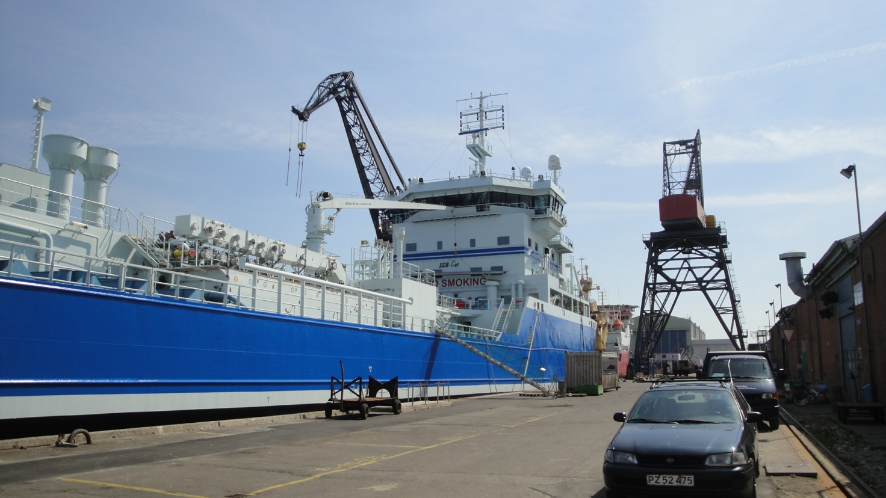

FAYARD A/S
Kystvejen 100
5330 Munkebo
Denmark

ISO 9001

1. Quality Manual

2. Introduction:

This document is FAYARD A/S Quality Manual.
The Quality Manual describes the overall structure and guidelines of the shipyards´ quality assurance system.
The management of FAYARD A/S has decided that the shipyards´ working procedures must be carried out in accordance with the ISO 9001: 2008 Quality Assurance Standard.
In connection with the above mentioned decision, the management is also aware of the commitment of support with required funds and resources in order to comply with the quality code. This is valid today and in the future. It is also the managements desire that the QA System is described according to the ” Keep it simple ” principles and the industry ” Best Practice ” rules. This in order to describe the real world, the actual daily work and not just a theoretical tool.

Docking and repair of ships and floating units.

This Quality Manual describes the quality policy of FAYARD A/S and the strategic quality goals. Furthermore the overall contents of the procedures are described. The management is obliged to meet the policies and strive towards the stated quality goals.
The Quality Manual should be used internally and is given to customers and suppliers, who want to achieve information about the Quality Assurance System.
It is also decided that this document and all quality and management documents are made in Danish. Important parts valid for foreign customers are translated into English.
The System topic.7.3 Development and construction, and the system topic.7.5.2. Validating of processes is not included in this QA system, due to no relevance.

Munkebo 01.03.2016

Thomas Andersen
CEO

List of Contents:

- Quality Manual
- Introduction
- Quality policies
3.1 Safety policy.
3.2 Environment protection policy.
3.3. Quality policy.

- Organization and Quality goals
4.1 Organization.
4.2 Responsibilities and competencies.
4.3 Requirements from customers.
4.4 Strategy goals for FAYARD A/S.
4.5 Methods to achieve the expected objectives.
4.6 Evaluation of quality goals and the system.

- Quality management system
5.1 Quality management system overall structure.
5.2 Quality manual.
5.3 Procedures and documentation. Document control.
5.4 Planning of quality.
5.5 Education and training. Job description.
5.6 Infrastructure. Buildings and machinery.
5.7 Working conditions, working environment, Safety organization.
5.8 Manufacture of product. Docking.
5.9 Review of contracts. Contract offer.
5.10 Working procedures.
5.11 Legal and regulatory requirements.
5.12 Inspection and testing.
5.13 Measuring and test equipment..
5.14 Communication with customers and vessels
5.15 Development and construction (not implemented).
5.16 Purchase.
5.17 Inventory.
5.18 Suppliers.
5.19 IT / EDB.
5.20 Safety and Environment.
5.21 Non conformities and corrective actions.
5.22 Audit.

3. Quality policies
Management has elected the following 3 policies that describe the overall Quality Management basic philosophy and objective of FAYARD A/S:
3.1 Safety policy
The goal of FAYARD A/S is to achieve zero occupational injuries and illnesses by continuously improving its prevention practices, awareness and controls.

3.2 Environment protection policy
Fredericia Shipyard A/S was founded in 1916, the name is now changed to FAYARD A/S and is owned by the Andersen family.
Fayard A / S is Denmark's largest repair yard. Our primary task is the repair, maintenance and conversion of ships. We have 4 dry docks and associated buildings, cranes and equipment that form the basis for carrying out our work.
FAYARD A / S aims to be the leading shipyard in the Northern Europe market for repair, maintenance and conversion of ships by leading the way with the use of new technology to protect the environment as much as possible.
We will continually work to reduce the environmental impact of our operations. We will do this by ensuring optimal utilization of resources and reducing the strain on the environment as much as possible. We are committed to preventing damage to the environment and prevent pollution.
3.3 Quality policy
It is the policy of FAYARD A/S to provide safe, efficient and quality repair of ships and other floating units. This translates into the following primary objectives: CL.5.4.1

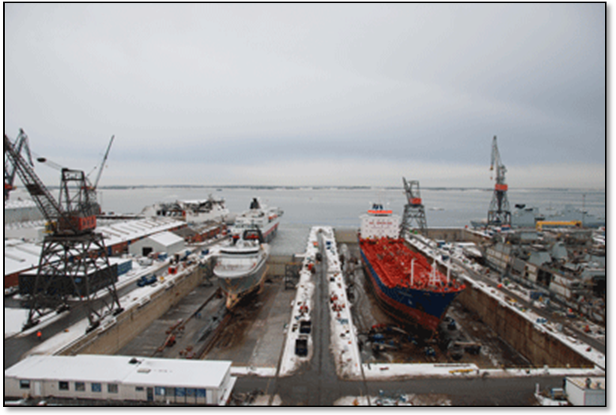

4.1 Organization chart

  - Responsibilities and authorities:
Responsibilities and authorities are found in the job descriptions. Job descriptions are available for key persons. The job descriptions are kept in the office of the CFO.
  - Customer requirements:
It is the target of FAYARD A/S that all service performed by the yard should meet the expectations of our customers and always comply with agreements made. This to be made in respect with the environment.
  - Strategy targets for FAYARD A/S:
Concerning repair, maintenance and rebuilding of ships, it is the objective of FAYARD A/S to become the market leaders in the Northern European region. Additionally, it is FAYARD A/S objective, through high quality, environmental behavior, competitive prices and delivery on time to ensure a satisfied range of customers as well as a good reputation in the market.
  - Methods for reaching the strategic targets.
To reach our targets, FAYARD A/S will prioritize safety, quality and delivery on time. FAYARD A/S will be on the cutting edge by using new technology and protecting the environment in the best possible way and ensuring that the work is being carried out efficiently and quickly.
FAYARD A/S will ensure that our employees are highly qualified with a focus on efficiency, quality and that the tasks are being carried out within time limits agreed, and at competitive prices.
A stay as short as possible at the yard is a crucial parameter for our customers. Through optimal productivity, good planning and targeted resources, FAYARD A/S will constantly work toward solving the tasks within the shortest possible time limit. This to be done with respect to the environment. One of FAYARD A/S new measures is to find new customers/markets through canvassing. This tool will help reach goals and collect “feed-back” from the markets, if there is anything we can improve and integrate into our system. The CEO has the responsibility for this.
  - Evaluation of Quality targets / the Quality system.
Our quality targets and systems will be evaluated once a year. The evaluation will be made by the CEO together with the person who is responsible for the Quality system. If any deviations in regard to quality or system are found, corrective measures will be taken to determine the time schedule for the implementation. A plan is prepared for the annual evaluations where any deviations and time table for corrections are recorded.
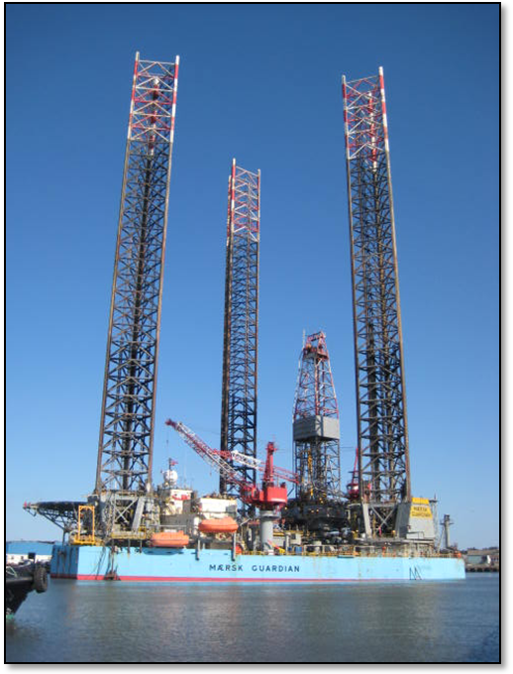
After each evaluation, the plan is signed by the CEO and the person responsible for the Quality system and is stored by yard management.
5. Quality management system

  - Quality systems general structure.
The structure of quality system consists of the following areas:
- Quality Manual (general description)
- Procedure for work etc.
- Checklists
- Section division (content) follows the requirements according to ISO 9001 standard.

  - Quality Manual.
The Quality Manual is a comprehensive summary of the Quality System. The CEO approves and is responsible for the Quality Manual. It must be available to all employees of FAYARD A/S.
The Quality Manual has to be sent and delivered to customers and partners according to requirements.
The Quality System is written in Danish, but relevant areas for non-Danish-speaking clients are available in English e.g. Quality Manual and various checklists.

  - Procedures and Documentation. Document Control.

    - PROCEDURES

The procedures outlined in the Quality System are described as follows:

- PURPOSE
- EXTENT AND SCOPE
- RESPONSIBILITY
- PERFORMANCE
- DOCUMENTATION
- REFERENCES

    - Documentation
To register and document the work functions, these will be described.

    - Document Control
All approved documents and checklists in the Quality System, must be under the Control Document in connection with the issuance, registration and approval. This is the responsibility of CEO.

  - Planning of Quality.
Short description of quality goals

  - Education and training. Job descriptions.
To ensure a high level of safety and to comply with all regulatory requirements, education and training are of high priority. The area is described in this section. Updated job descriptions are available for key employees.

  - Infrastructure. Buildings and machinery.
The Yard's infrastructure is registered, checked and documented. This includes, docks, buildings, machinery and cranes, etc.

  - Working conditions. Work environments. Safety Organization.
The work environment has a high priority and as a result of this, a number of safety groups in various departments, have been created, with elected safety representatives. Furthermore, the CEO is a member of the Safety Organization.

  - Product Manufacturing. Dockings.
FAYARD A/S appears and wants to remain the leading ship repair yard in Northern Europe, with quality work of the highest standard. Dockings performed are therefore
in high quality and on time.

  - Contract review. Quotation.
Quotations are prepared according to Danish Maritime and the customers' specifications as well.

  - Operating procedures.
This section describes a wide range of work procedures performed during the daily work. This includes e.g. In and out dockings, coating, welding, valves and procedures for fire guards

  - Legal and regulatory requirements.
The legal requirements are observed and complied with, according to e.g. Working Environment Act, substances and materials, workmanship and technicalities.
Requirements are controlled and verified by Class/standards and the Inspector.

  - Inspection and testing.
A comprehensive series of inspections, issuing test certificates are performed. This includes e.g., crack tests of the rudder, pressure test of hoses, load testing of cranes and pressure testing of tanks.

  - Measuring and testing equipment.
The applied test equipment for inspection and testing, is tested and certified in accordance with applicable laws.

  - Communication with the customer / the ships
Customer contact and cooperation with customers is based on a very long and close cooperation and mutual trust. Communication with the customer and ships are unpretentious, comfortable and with mutual respect between the parties. Agreements in connection with docking workers are always written.

  - Design and Construction.
Procedure not included.

  - Purchasing.
Many purchase orders are ordered by the Vessel. A selection of purchased products is verified and registered upon receipt at the warehouse. Also vendor ratings according to agreements and lessons learned are made.

  - Inventory.
The inventory is controlled manually. The warehouse employees inspect the inventory daily, follow up on any lacking items, and follow up, and make purchases.

  - Sub Contractors.
The largest suppliers are evaluated and approved by FAYARD A/S

  - IT / Computer
Security regarding IT is of high priority and there are backup procedures used for the software.

5.20 Safety and Environment.
Safety at a high level is extremely important in the maritime industry and FAYARD A/S always aim for a very high safety standard. There are contingency plans and permits for some risky jobs such as, Welding Work, gas measurement and access to enclosed spaces. There is high focus on the environmental areas and sorting of waste and sewage from ships. This includes oil and waste water from tankers.

5.21 Deviations and corrective actions.
It is essentially in the quality system, that deviations are detected and corrected in the daily work and during audits. This is recorded in the deviation reports and in the dock lists.

5.22 Audit
Internal audits are conducted annually and cover the entire quality system. Internal audits are planned on the basis of the audit plan.

The content in this book includes quality records and these are filed according to agreement.

